**Practical 1**

**AIM: Installation of Virtual Machine Software**

Procedure:

1)Open your Web browser and search VMware download

2) Click on the first link ( <https://www.vmware.com/in/products/workstation-pro/workstation-pro-evaluation.html> )or copy and paste from here.

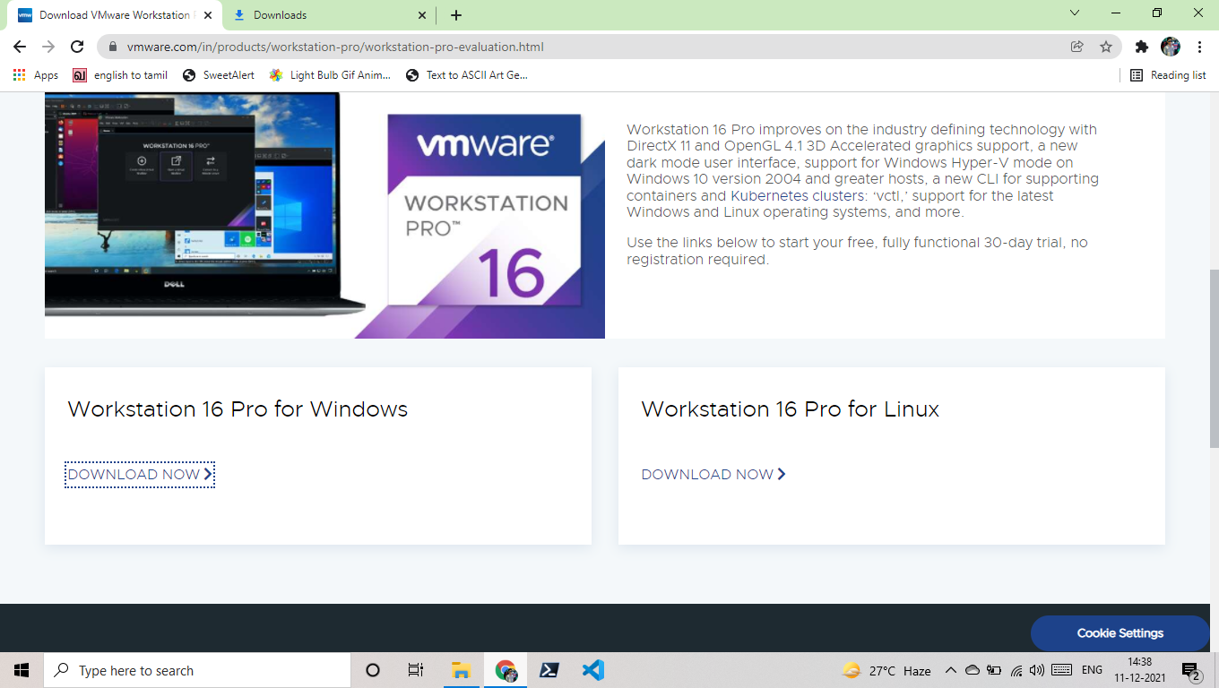3) Click on the download button (DOWNLOAD NOW)

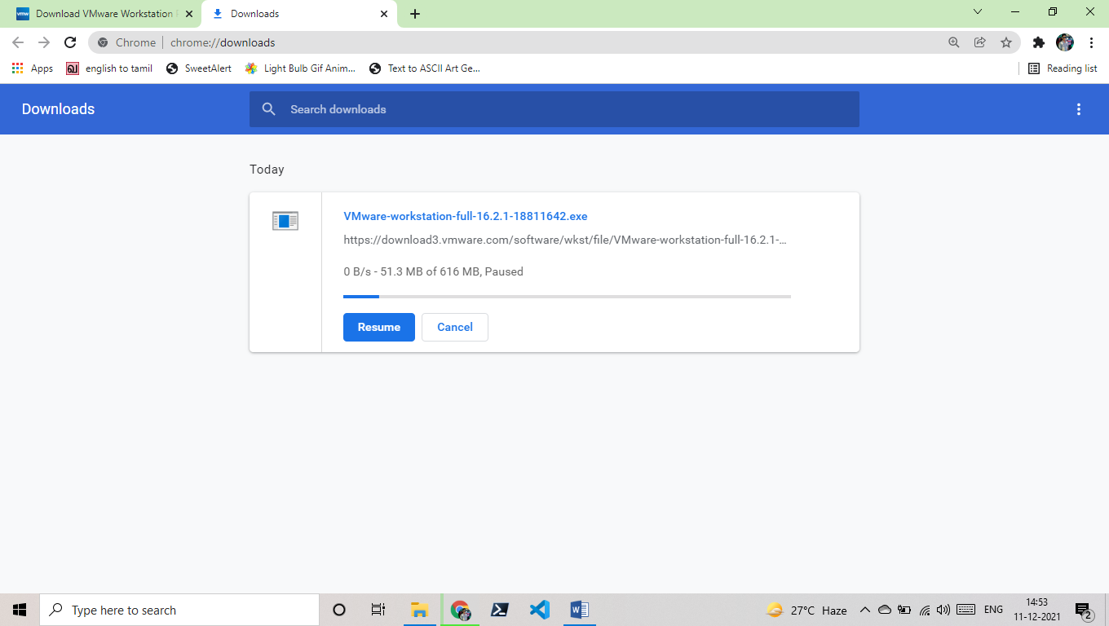4) Then The software will automatically start downloading (if not start do these again).

**Practical 2**

**AIM: Installation of Linux operating System (RedHat/Ubuntu) on virtual Machine**

Procedure:

1) On your browser search ubuntu download and click on the first link ( ubuntu.com/download/desktop#download )

2) Click on Download and then click on the ubuntu desktop and download that.

3) It will start downloading ubuntu iso file.

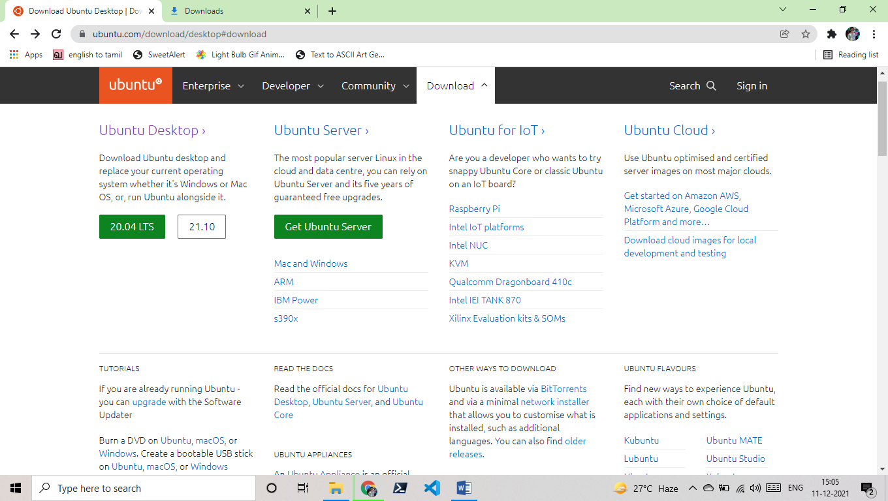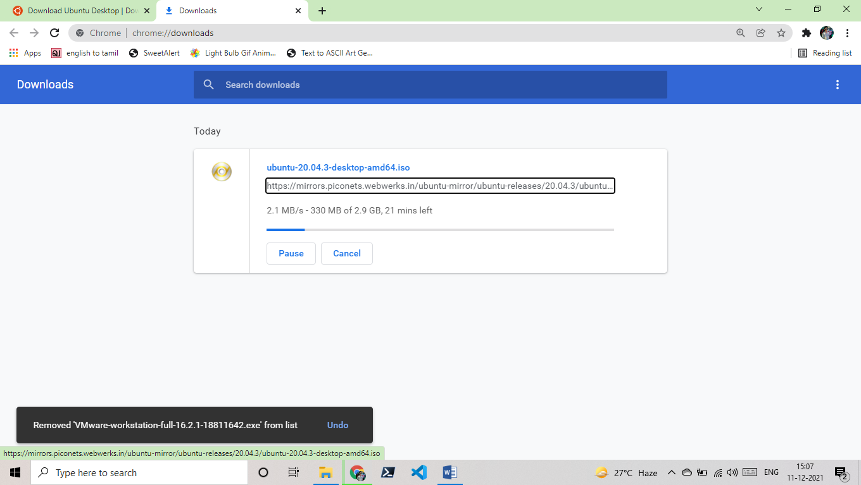4) Check your downloads in browser.

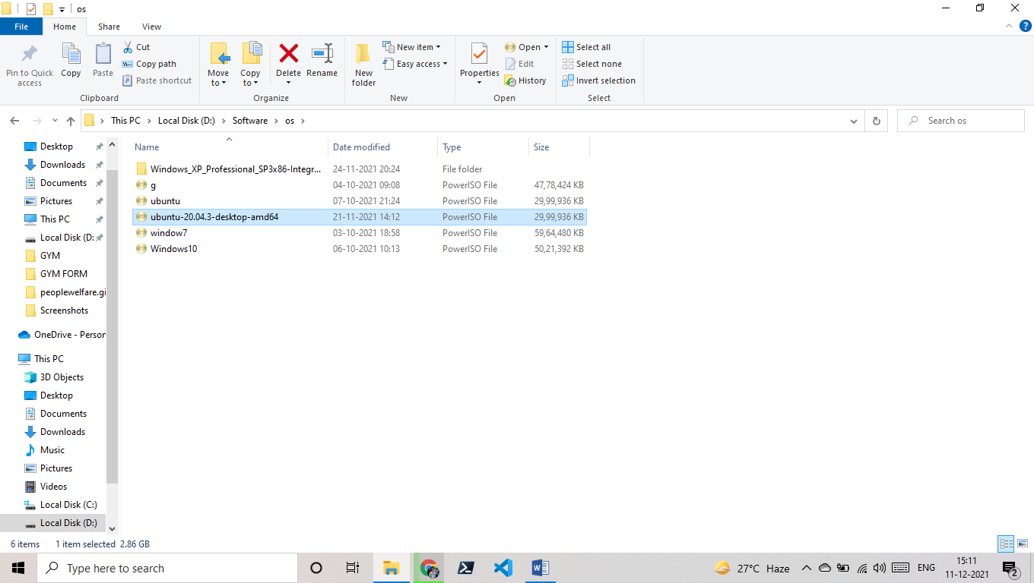5) After downloading you can see an iso file of ubuntu.

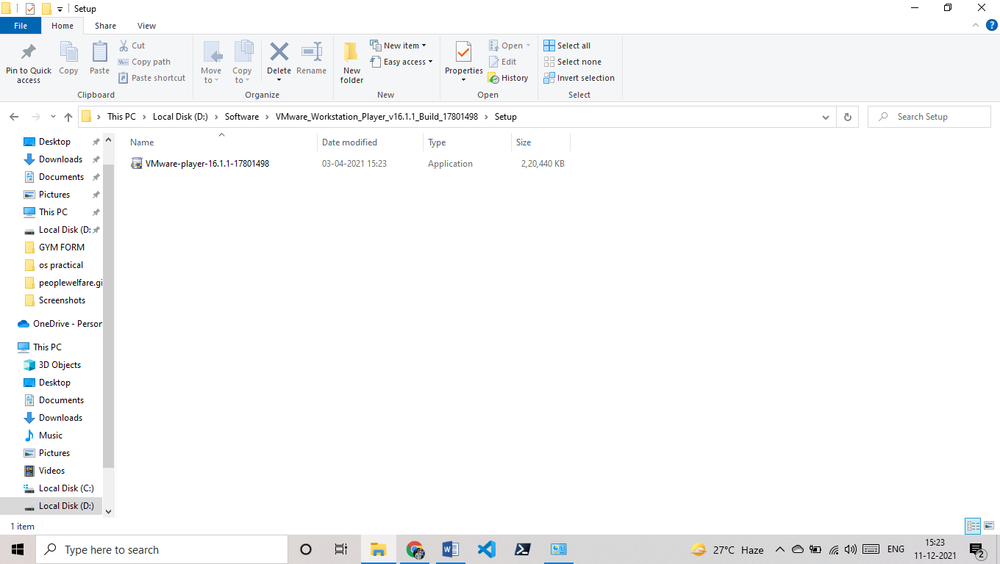6)Now go and run the VMware app file.

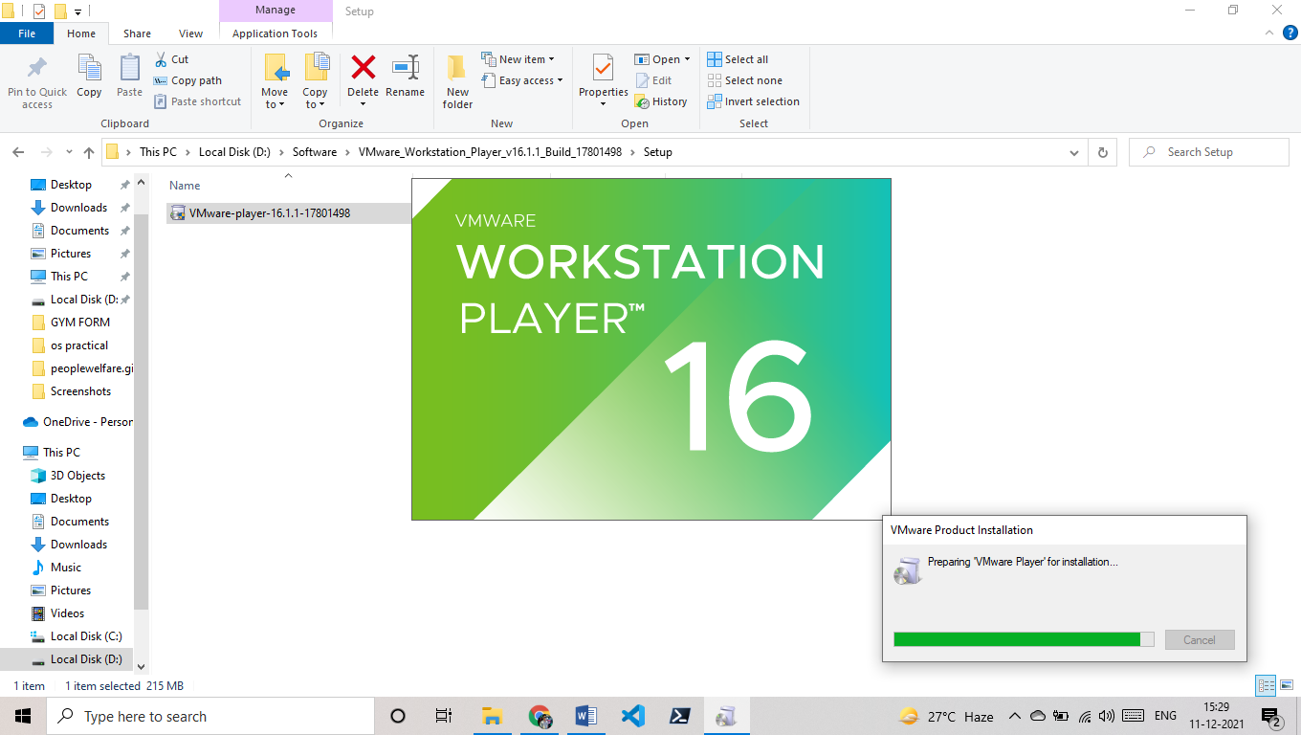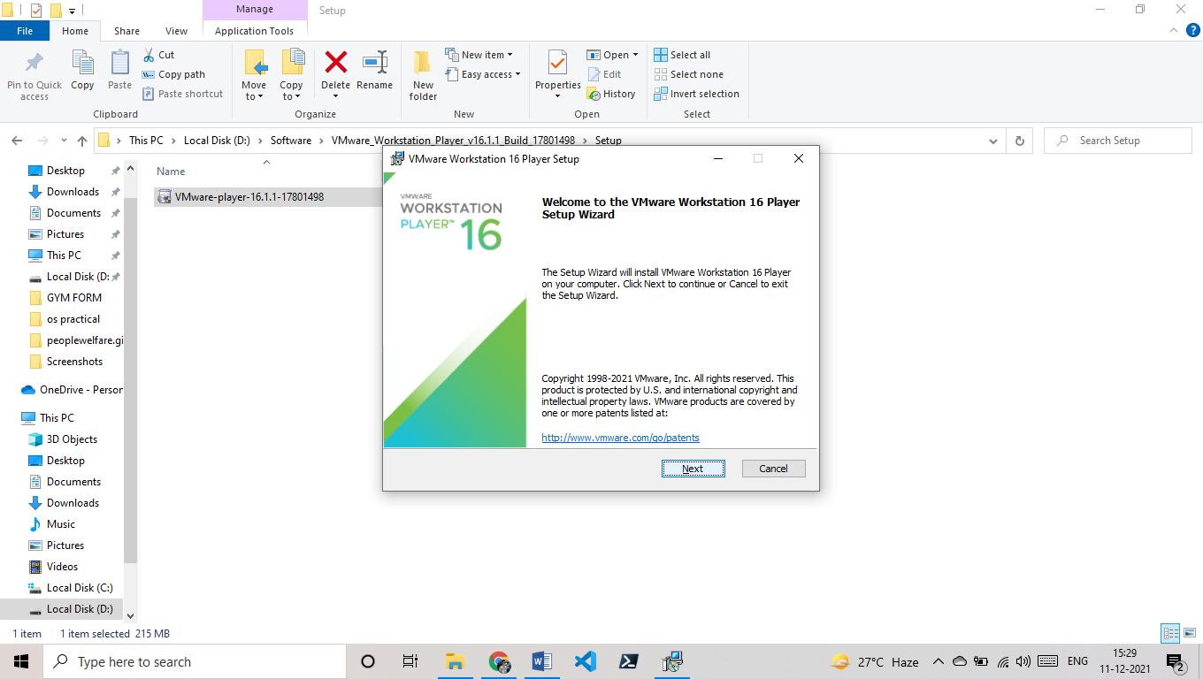

7) Click on next for everything

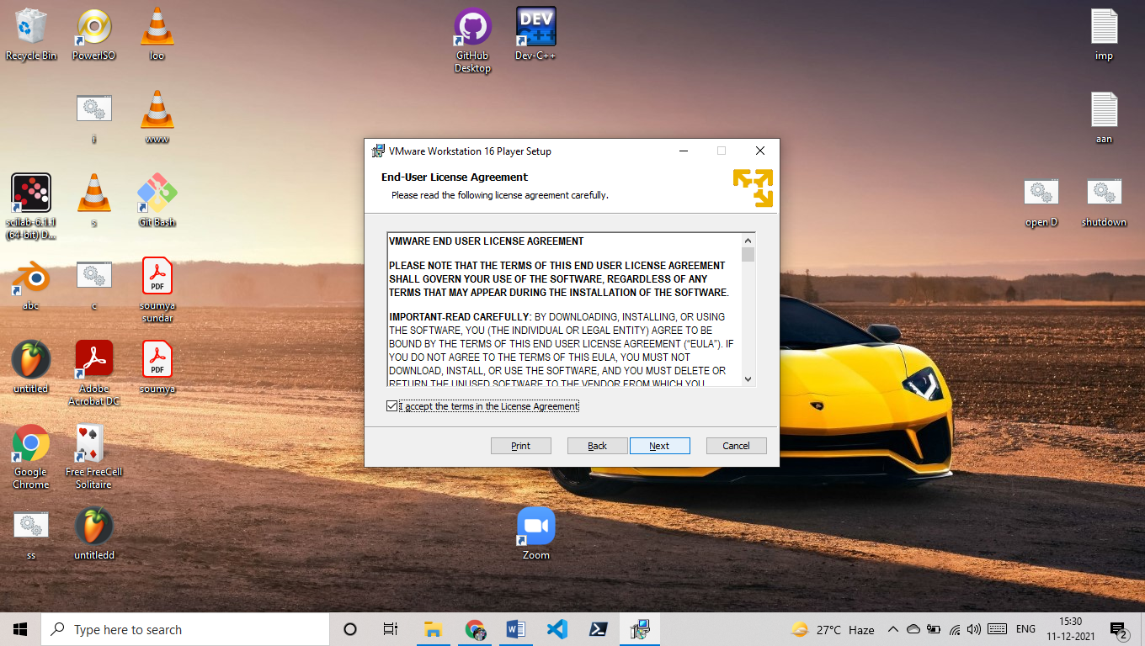

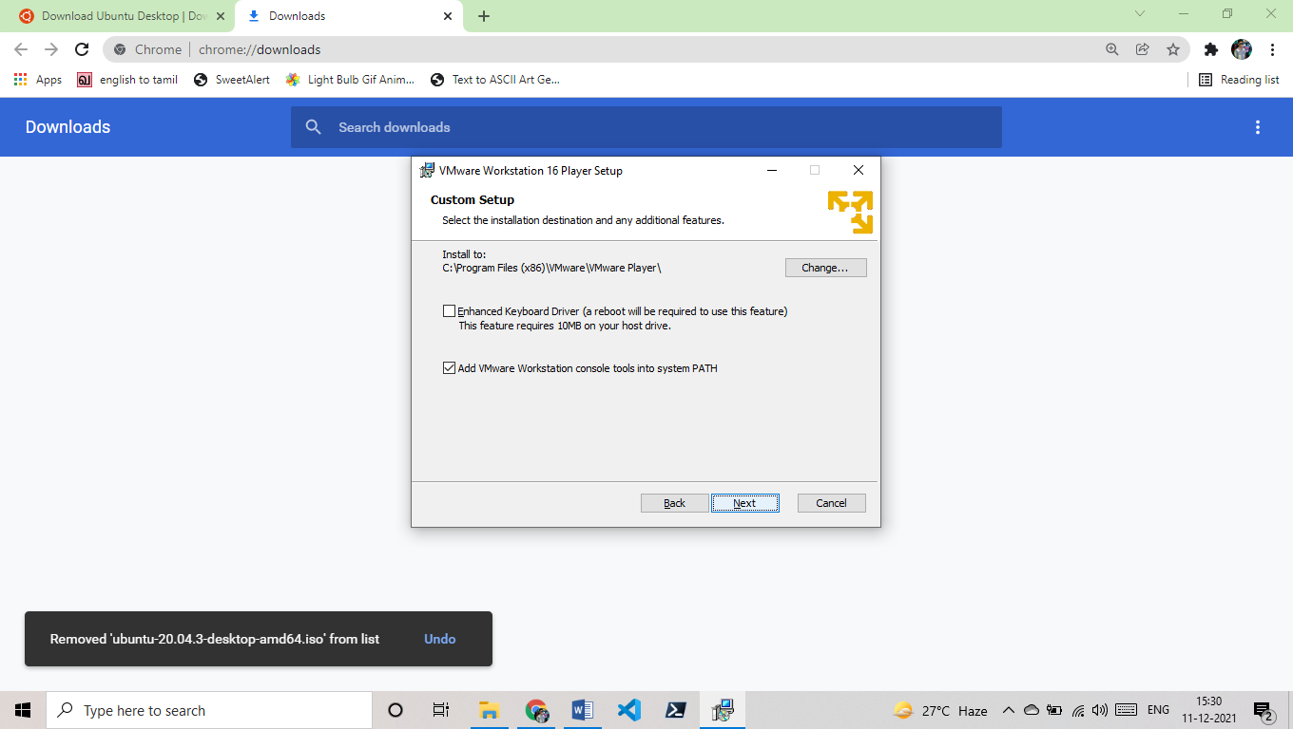

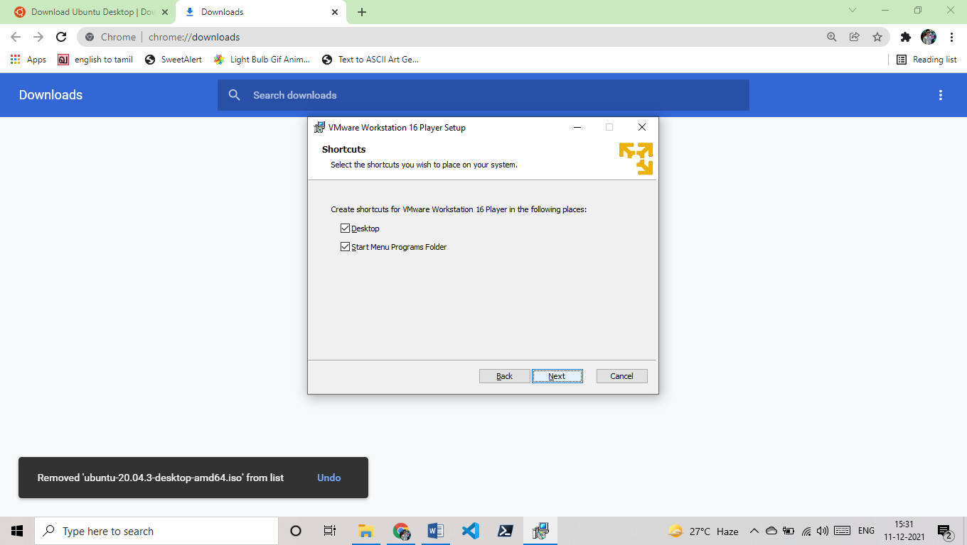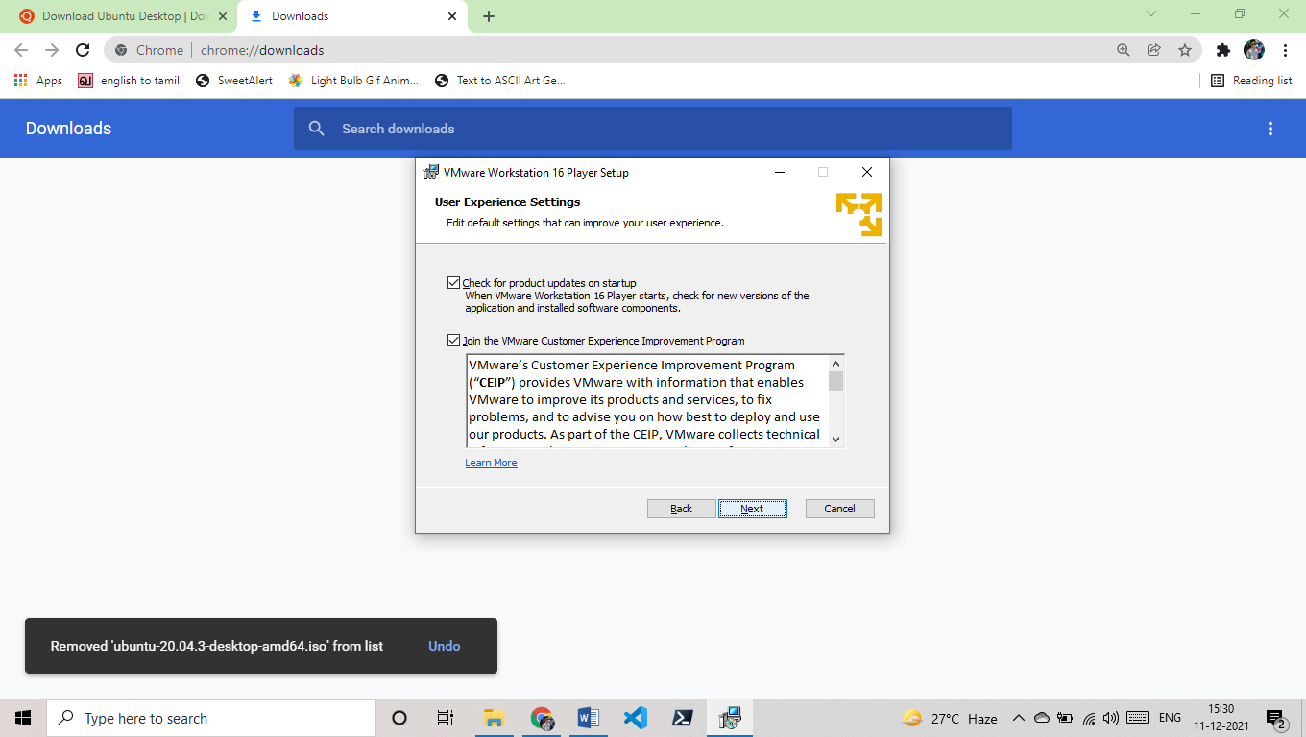 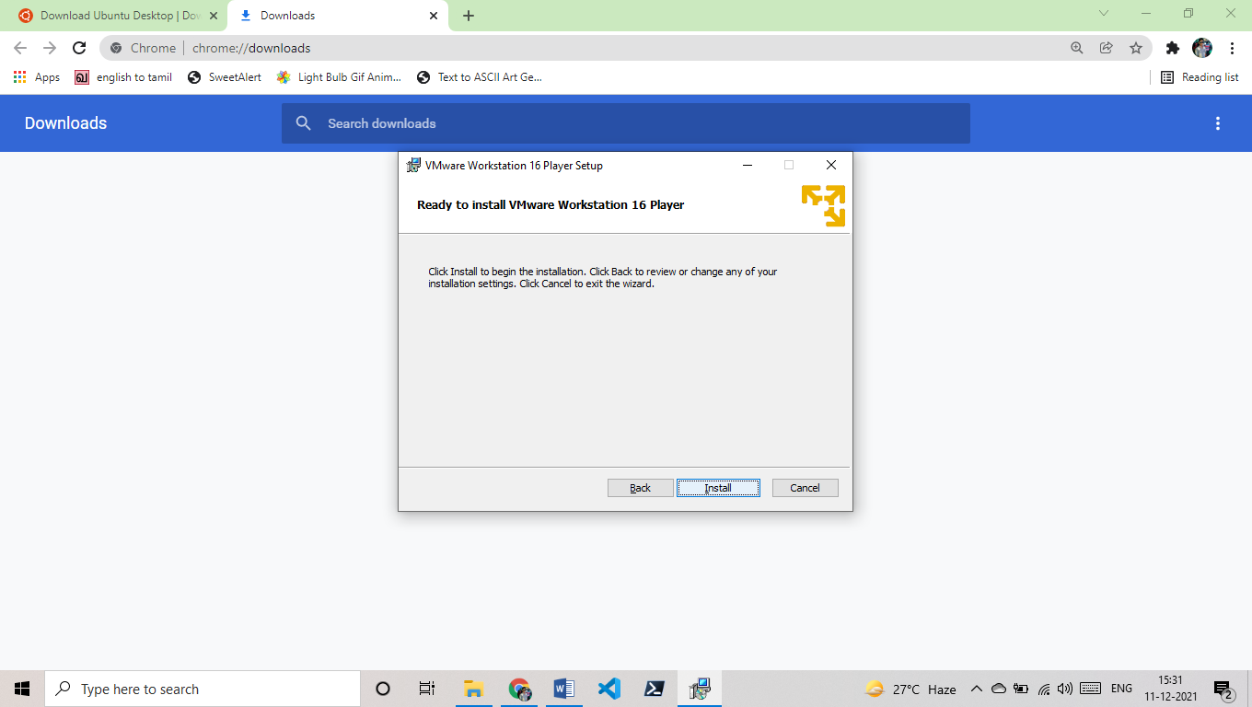 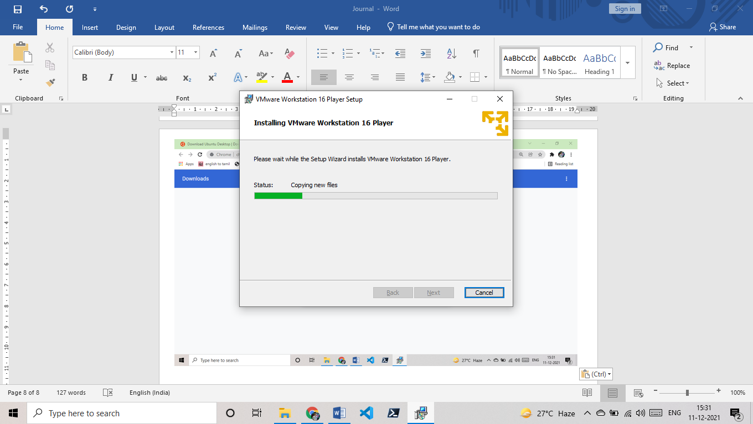

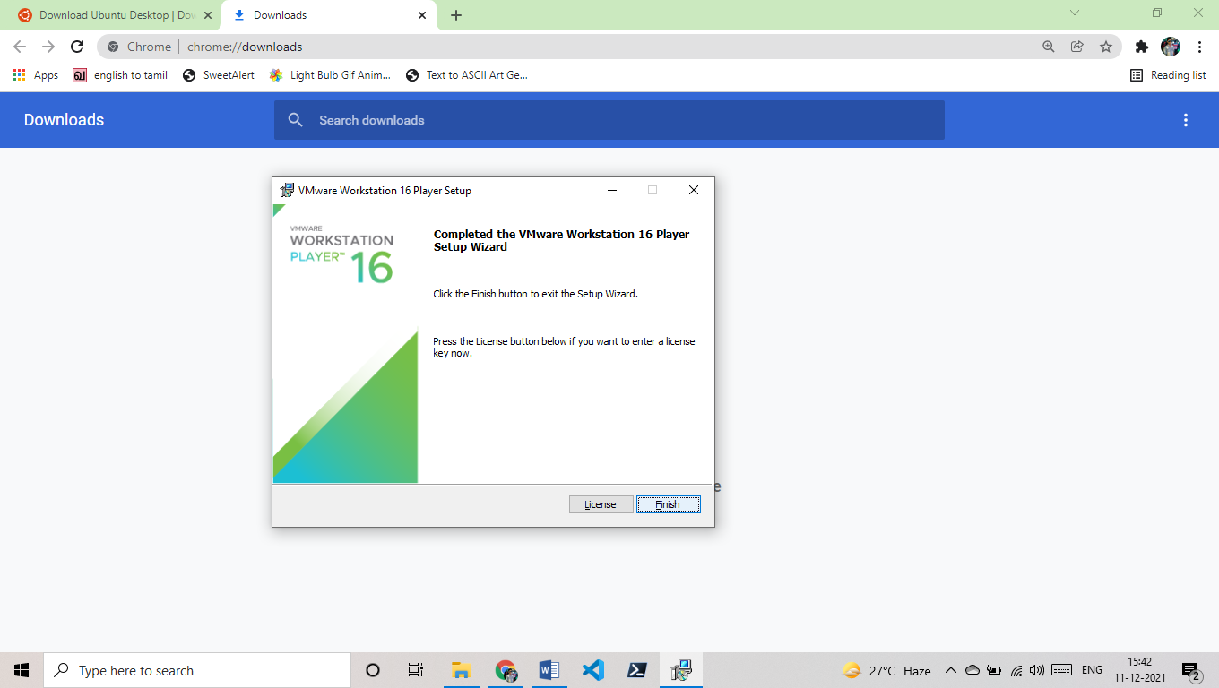

8) installing ubuntu in VMware.

9)open VMware.

10) Click on create new virtual machine.

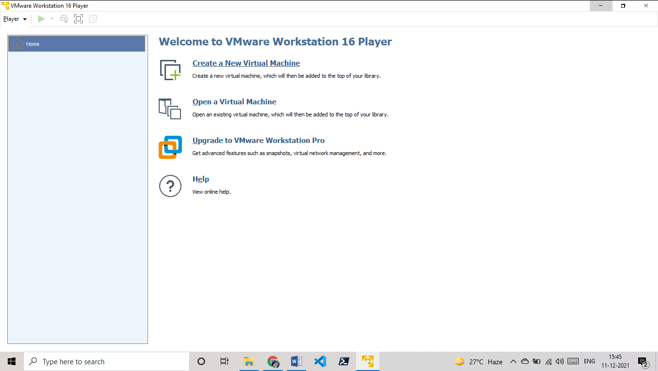

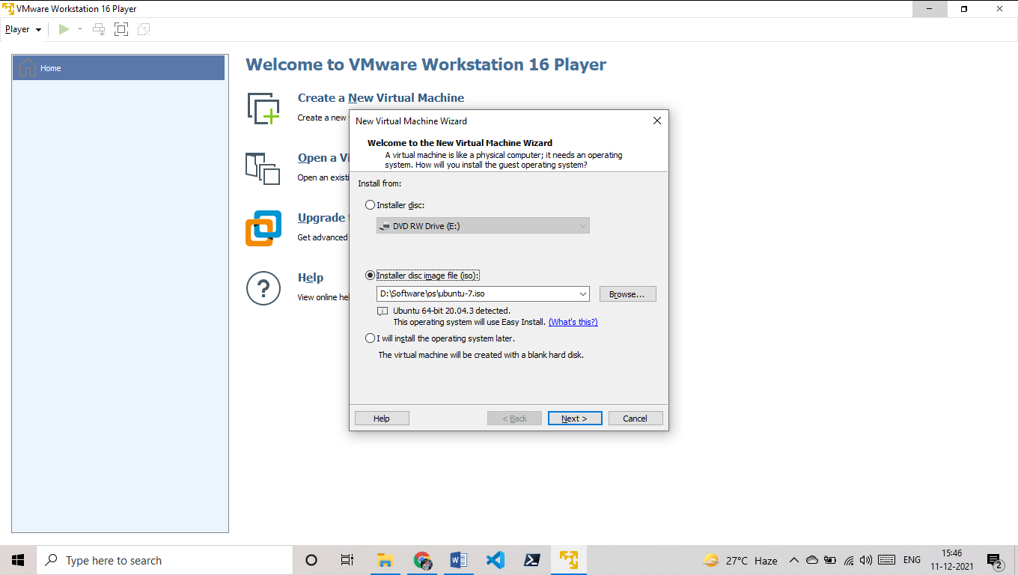

11) Click on browse and open your iso file ok do next by above image.

12) fill the detail and click next.

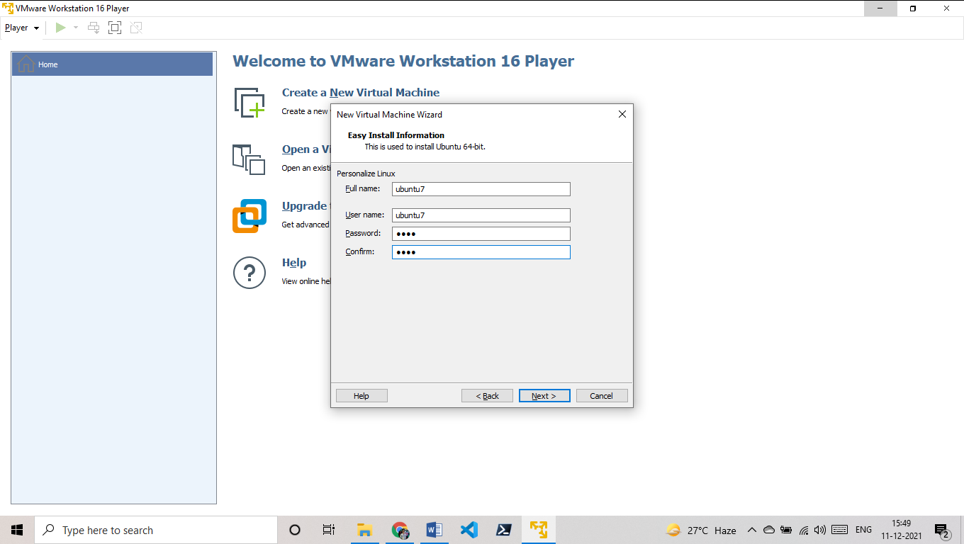

13) give name and add the location of virtual machine.

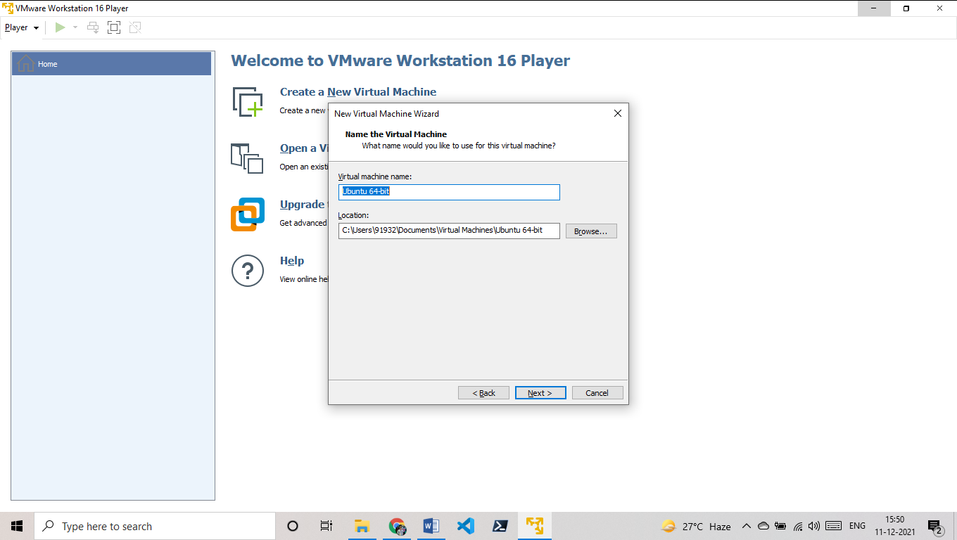

14) Give disk size for your ubuntu OS (I am giving default 20gb).

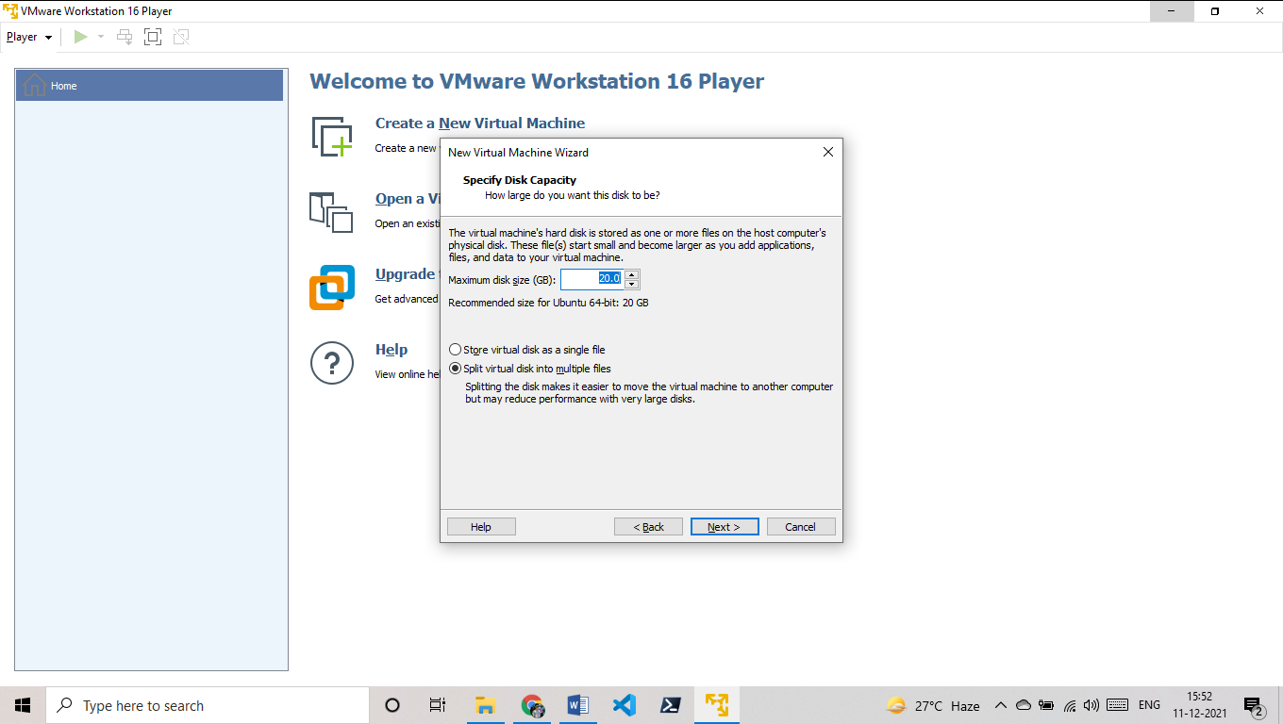

15) You can customise more for now I am doing finish.

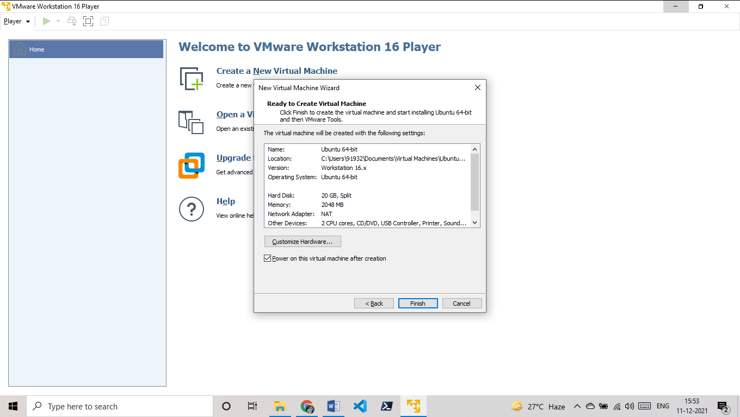 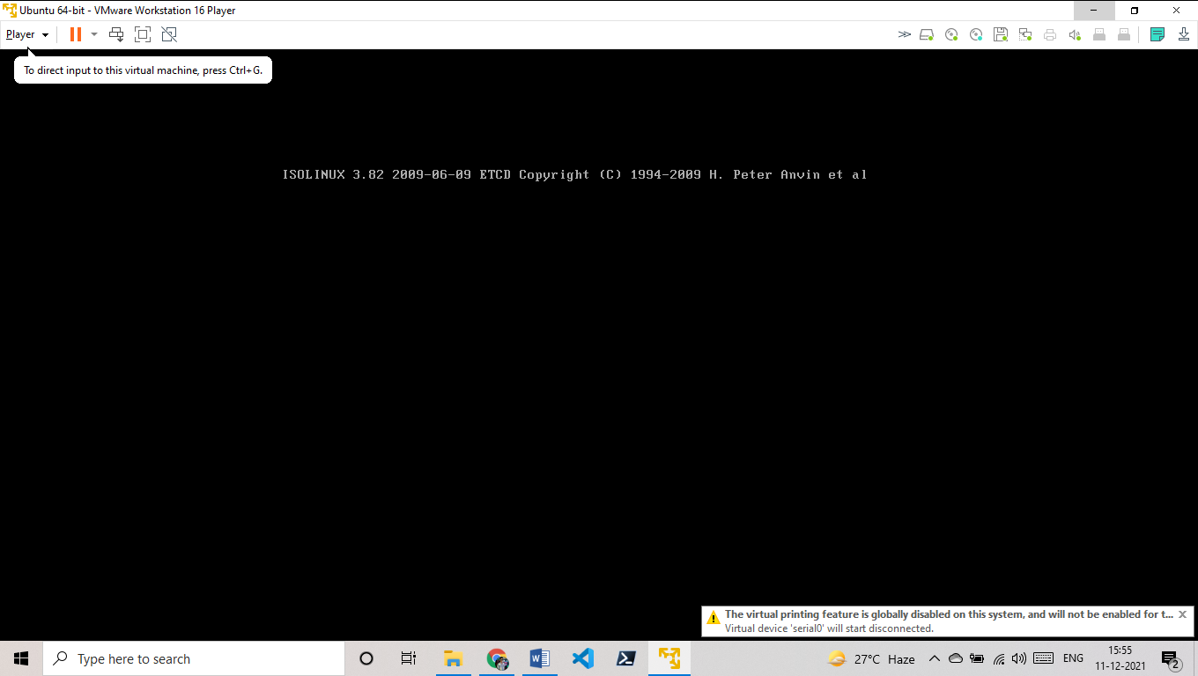

It will check disk

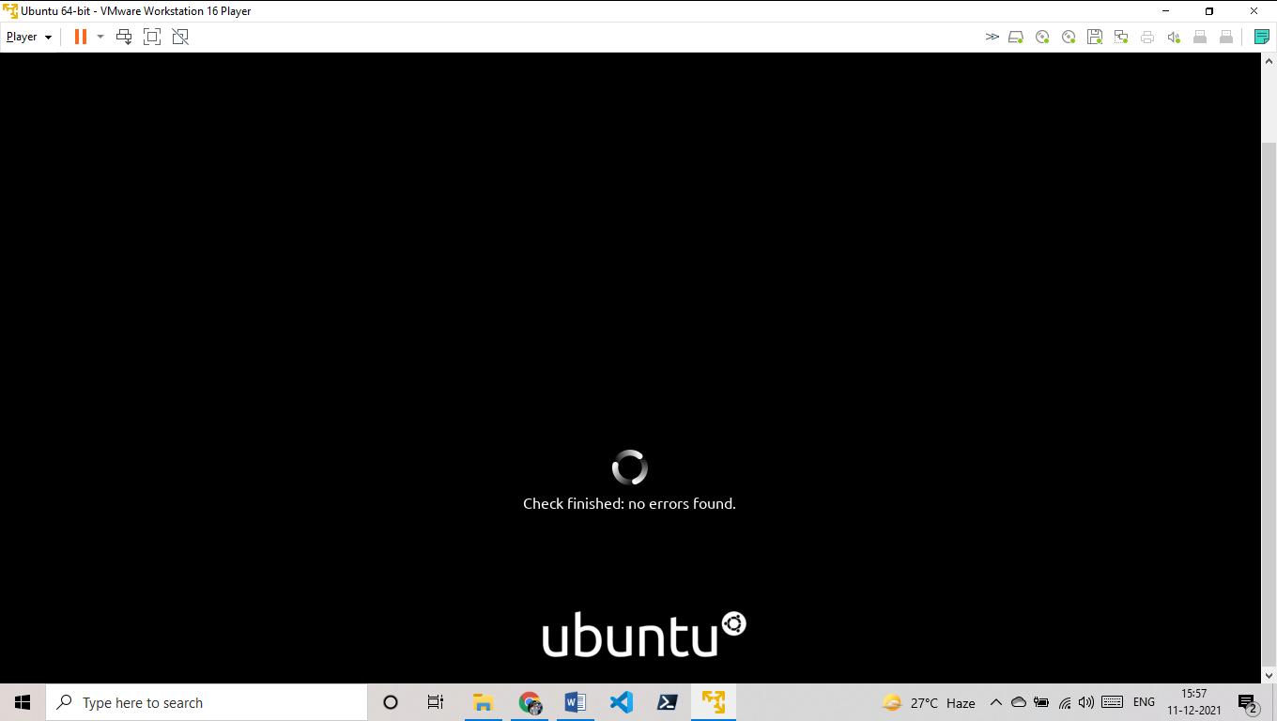

It will load

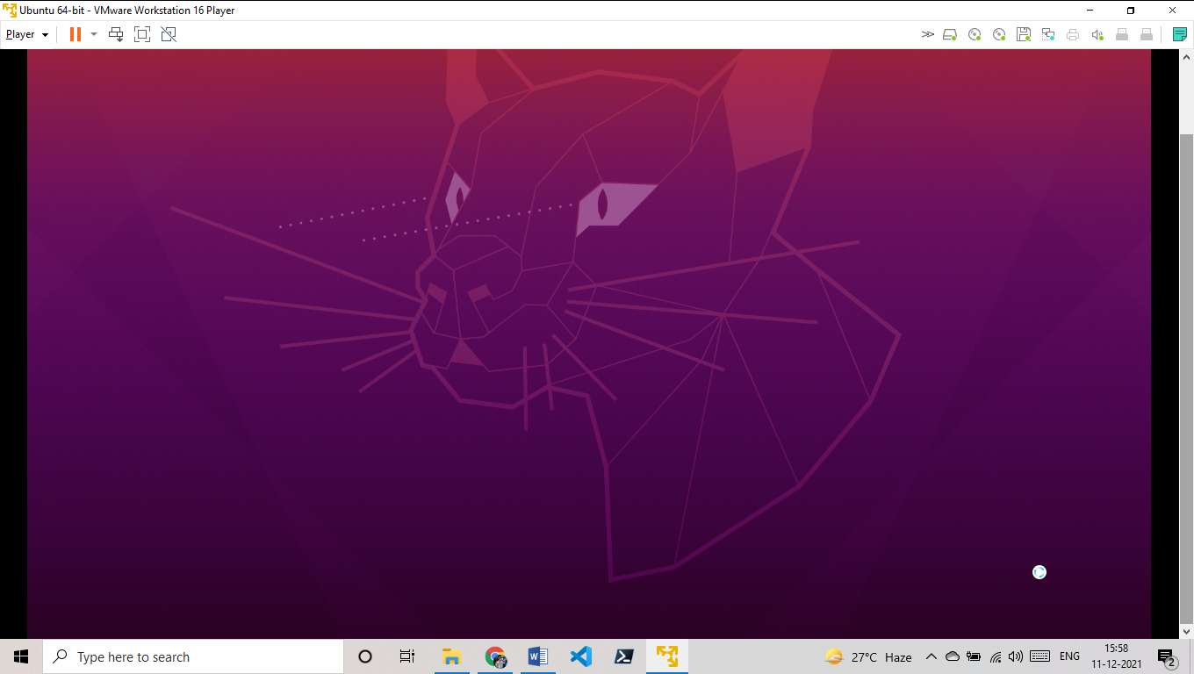

It will Verify

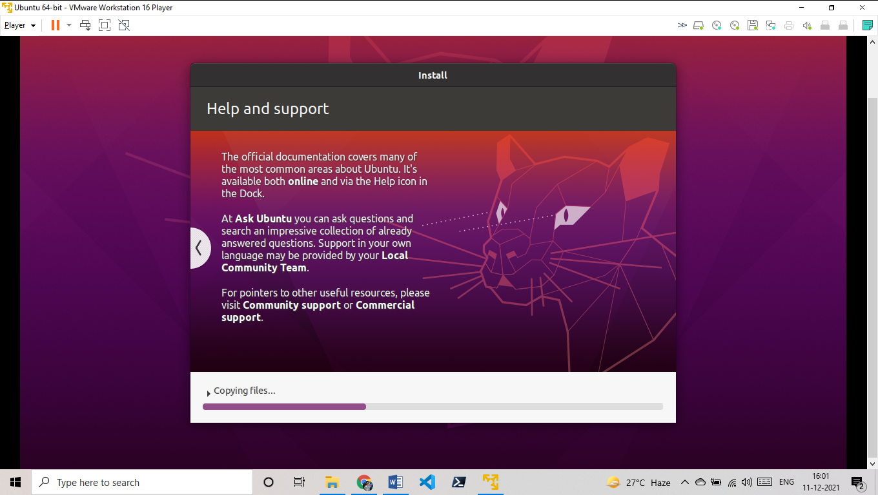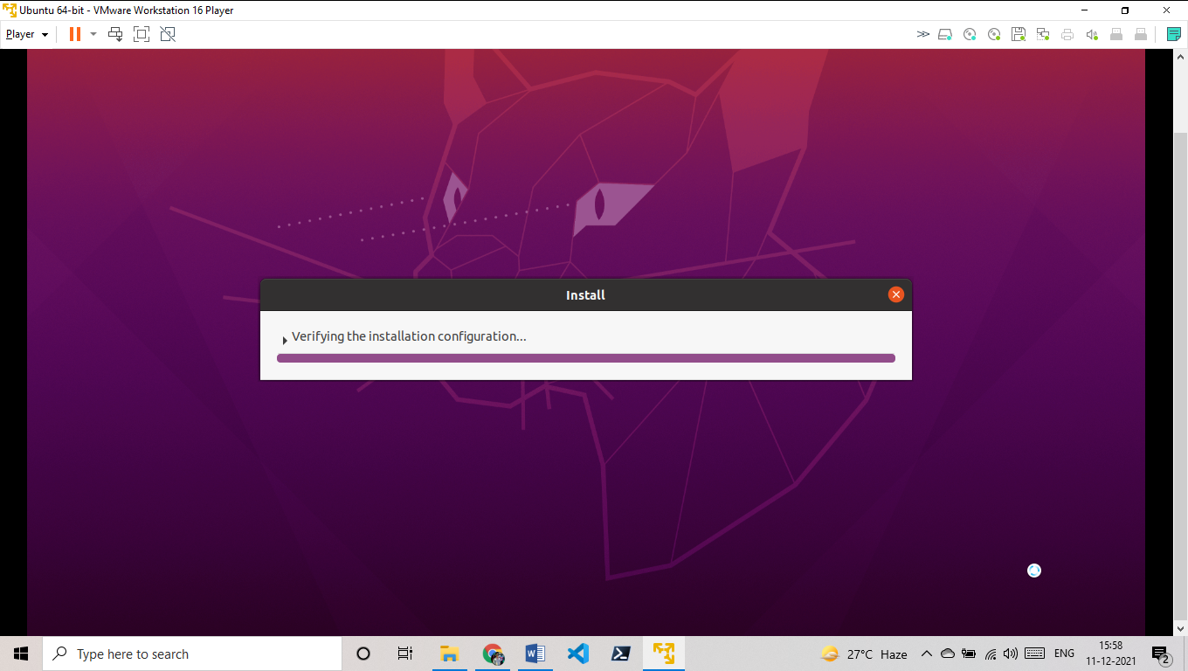

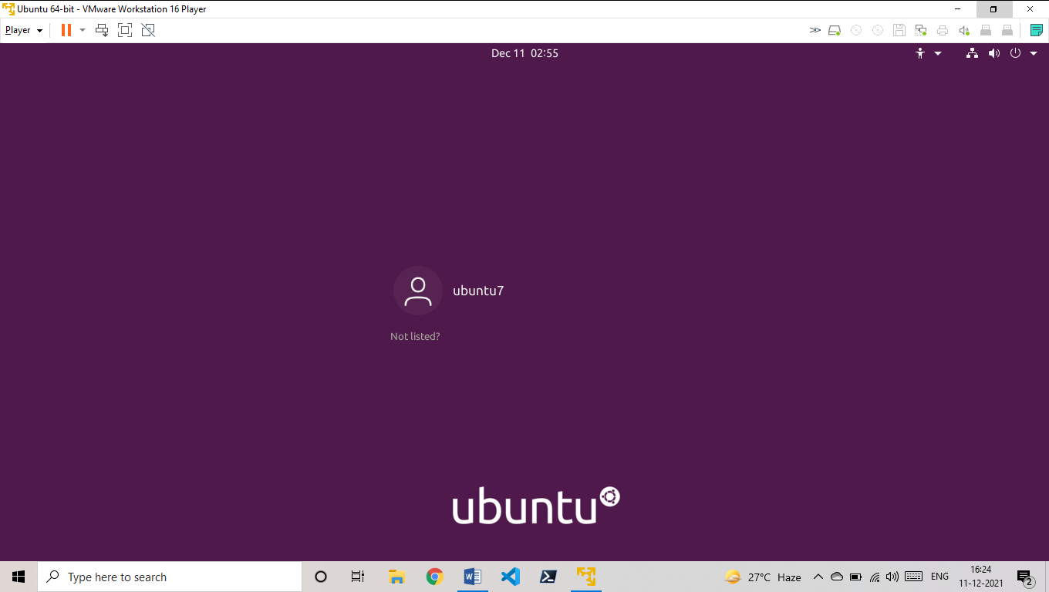

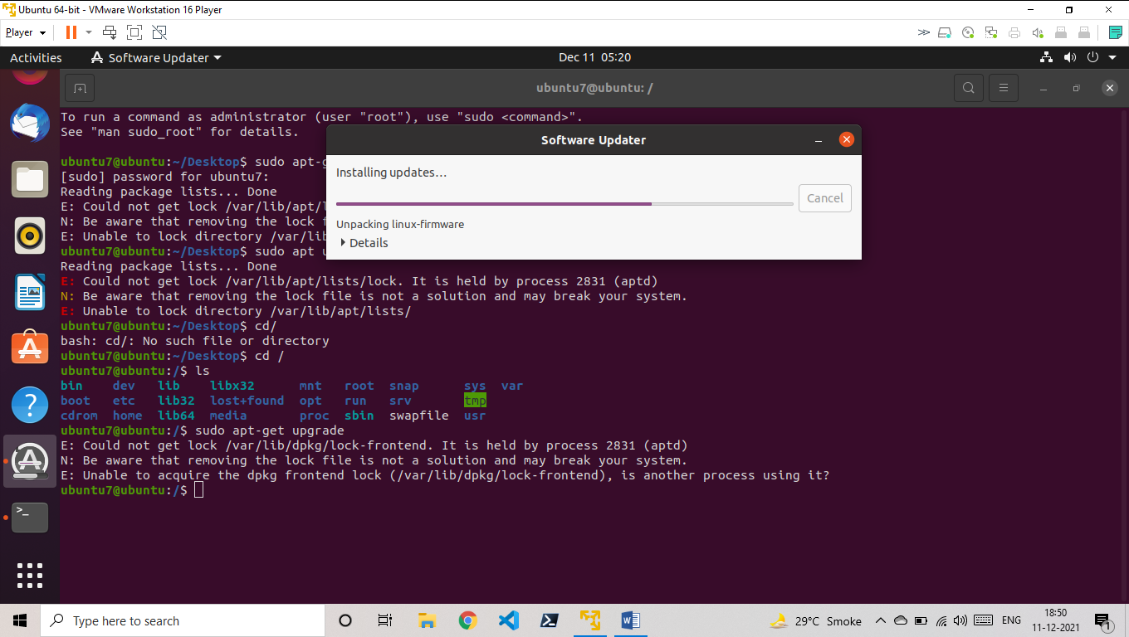

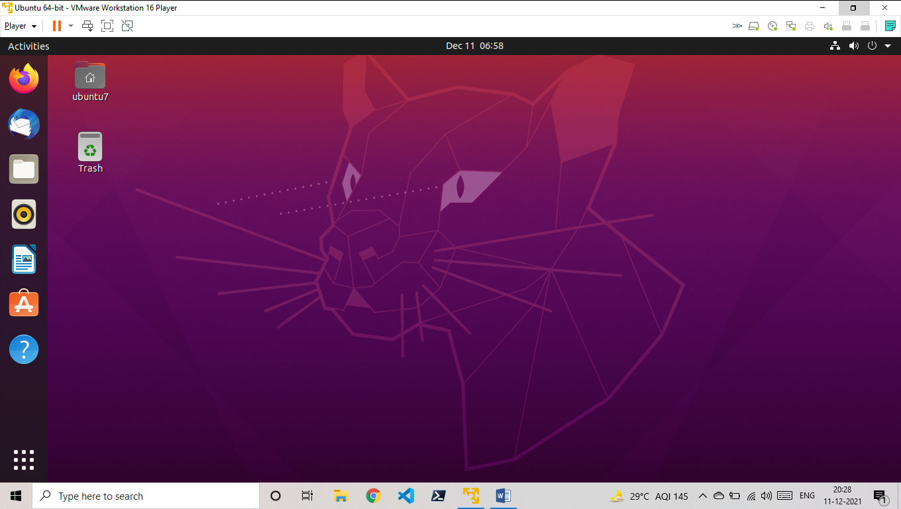**Every thing is now set**

**Practical 3**

**AIM: Installation windows operating System on virtual Machine**

Procedure:

**Practical 4**

**AIM: Linux Command: Working with Directories:**

1. pwd, cd, Absolute and relative path, ls, mkdir, rmdir.
2. File, touch, rm, cp, mv, rename, head, tail, cat, tac, more, less, string, chmod

Procedure:

1)**pwd.** :(Print working directory) show to the location of the terminal.

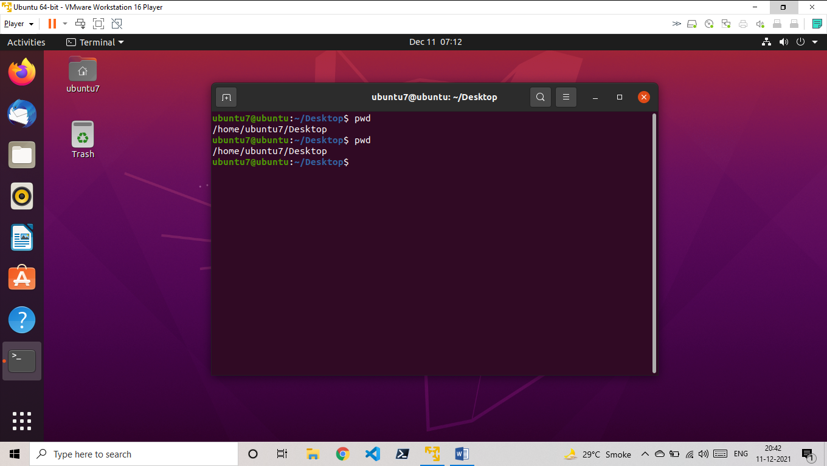

2)**cd :** (change Directory)change the path from one to another.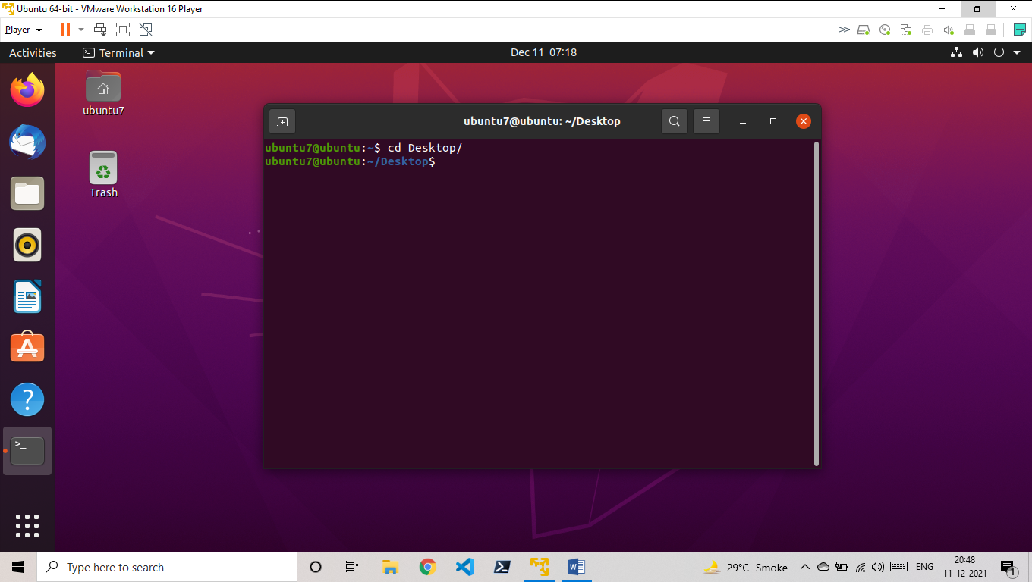

3)**Absolute and Relative path:**

4)**ls** : {List files}

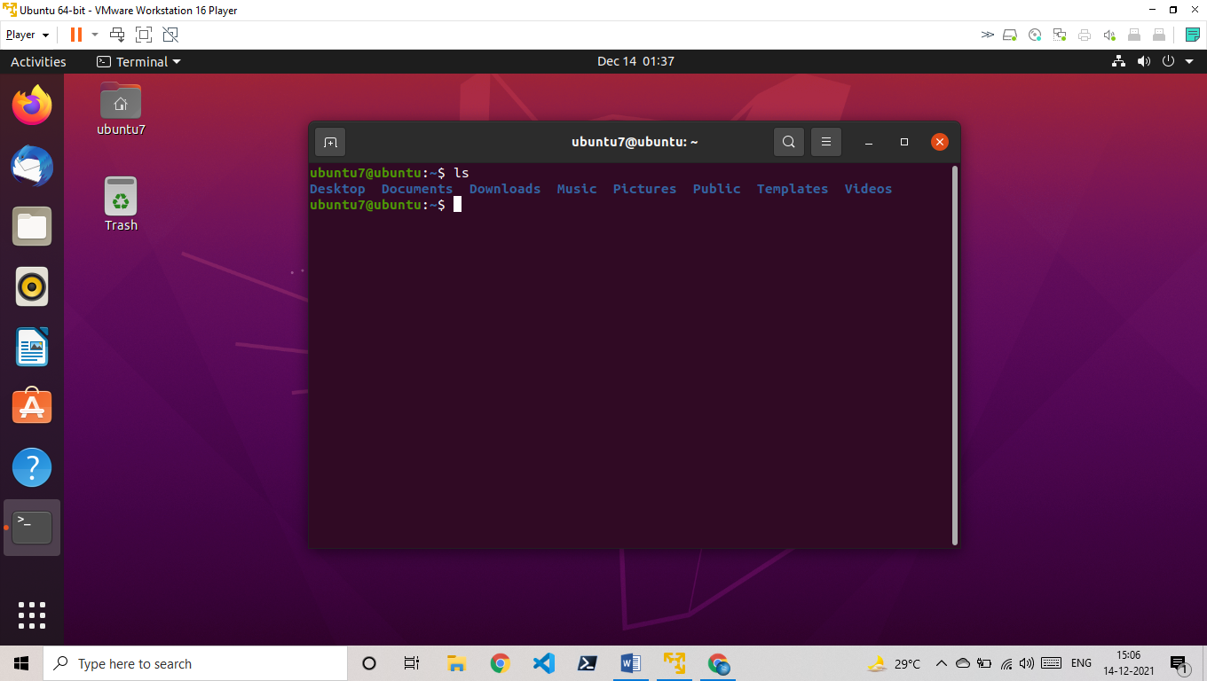

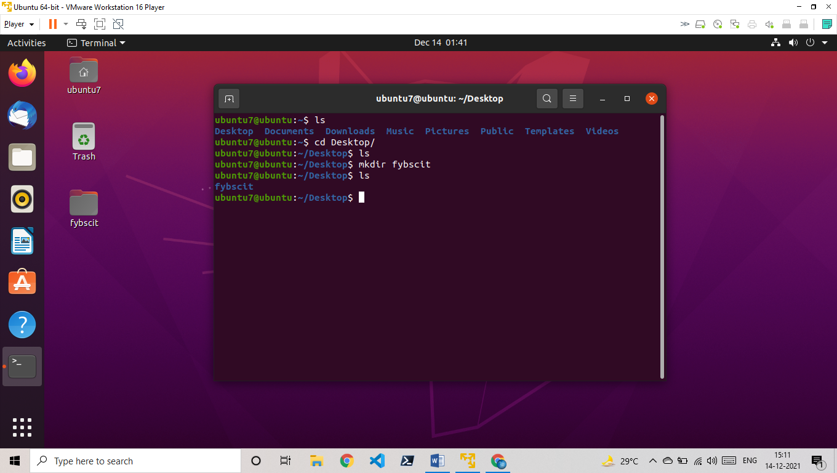5)**mkdir:** (Make new directory)

6)**rmdir:** (remove directory)

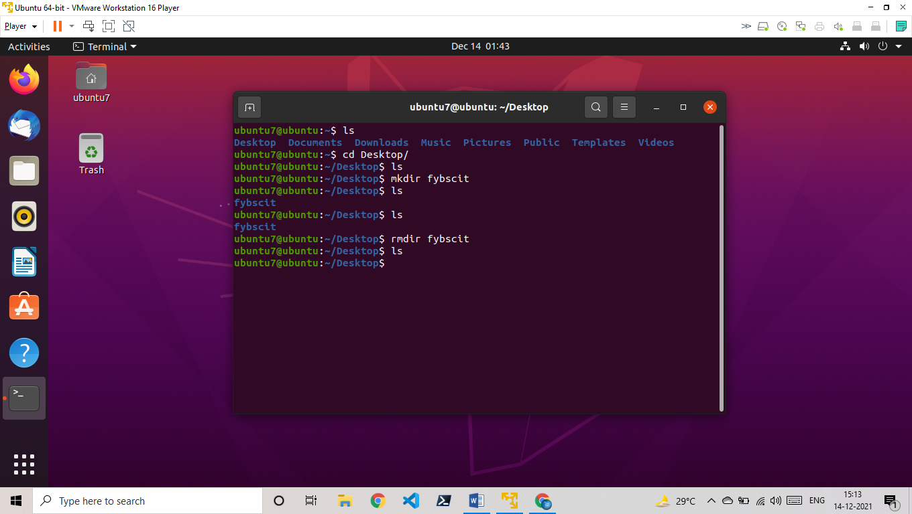

**B)** 1)**File** (show the file type)

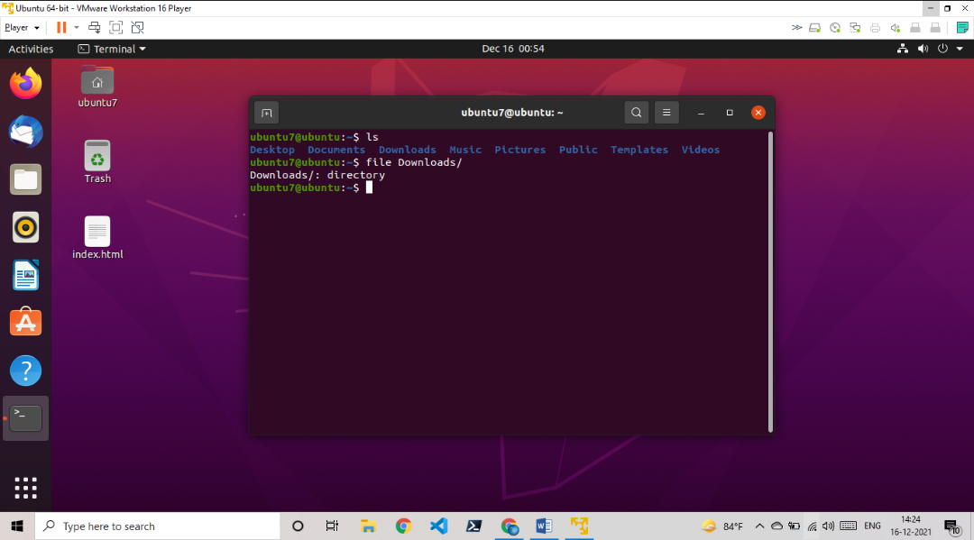

2)touch (create new file)

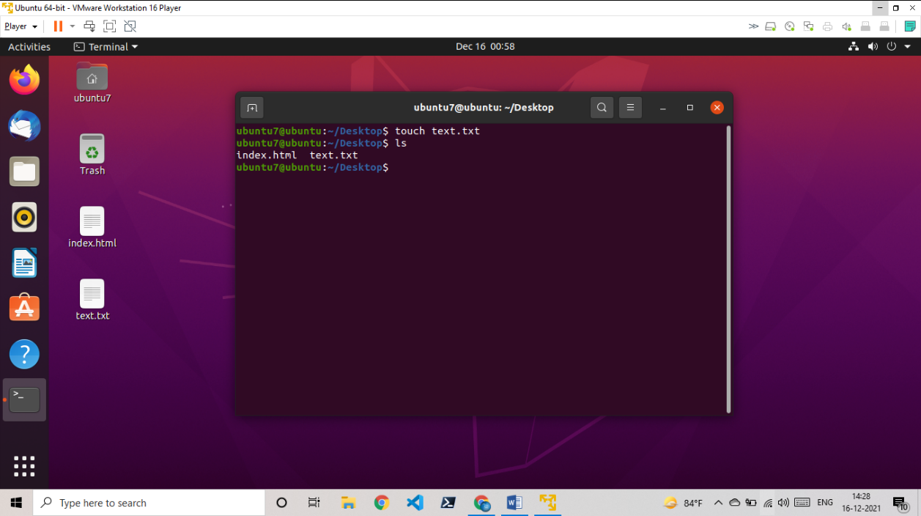

3)rm (remove file)

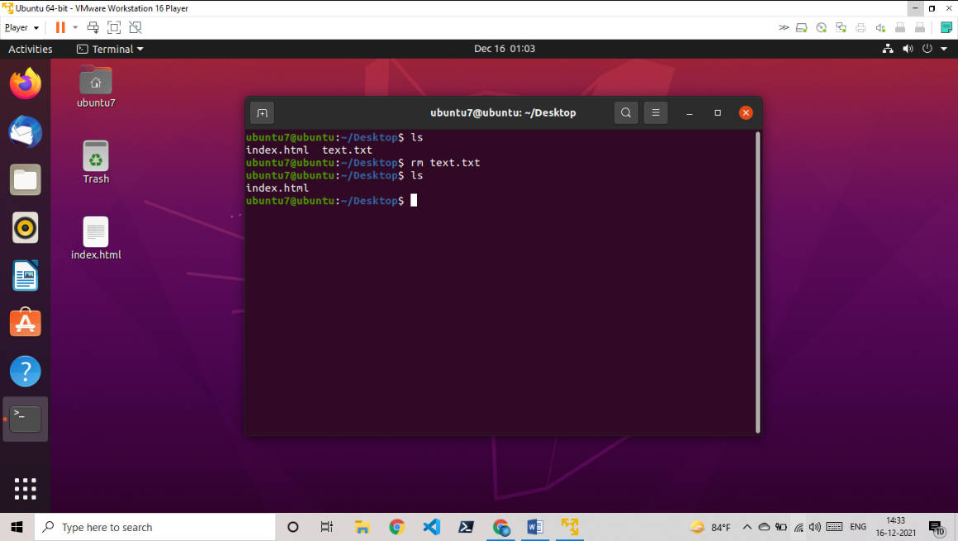

4) cp ( used to copy files from one to another location)

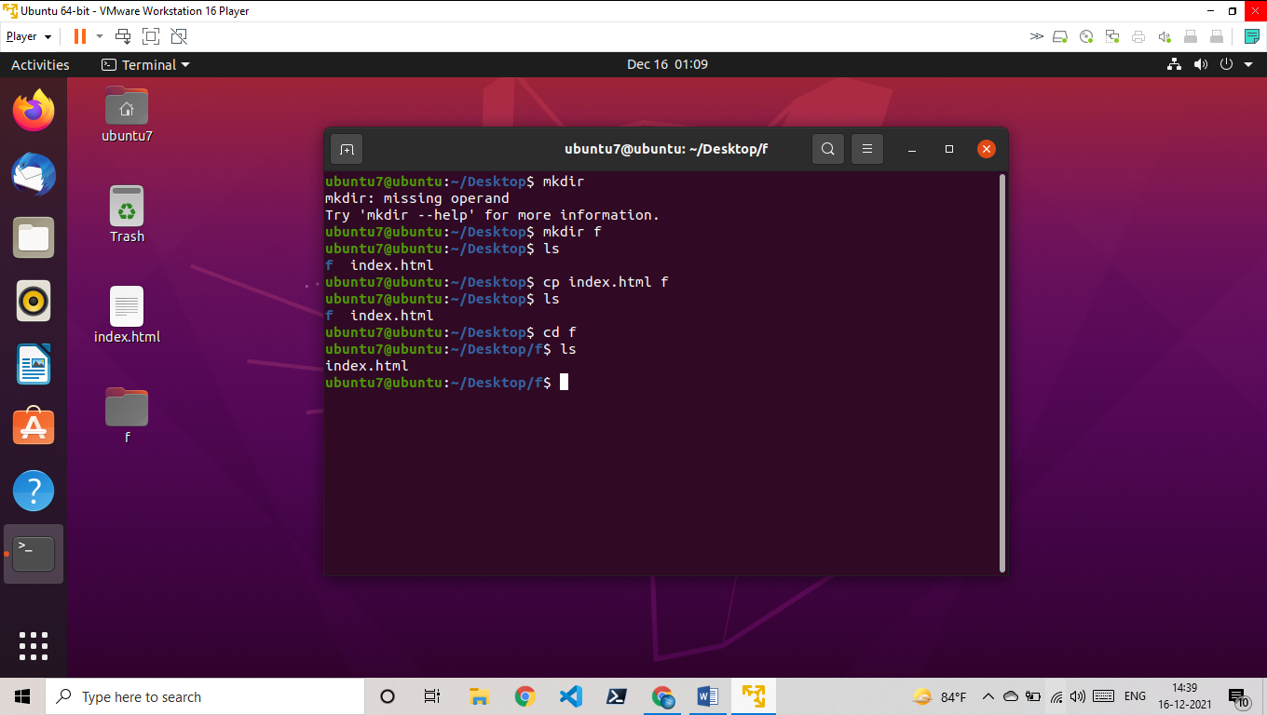

5)mv (used to move files from one to another location)

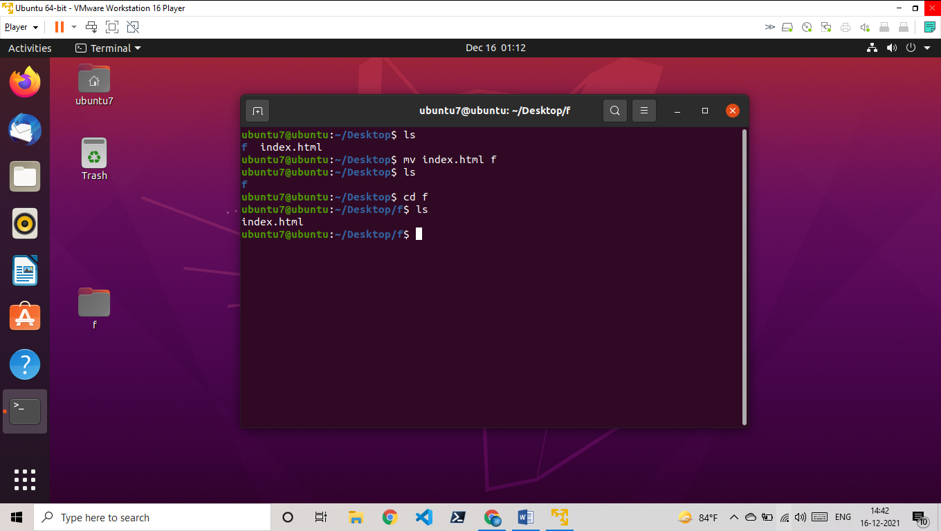

6) rename ()

Mis will teach